Effects of Netflix on Movie-Going
Cade A. Thomas
Communications Research Methods (Spring 2018)
Dr. Juliet Evusa
Rogers State University

Abstract
This research paper explores the rise of online streaming services, in particular Netflix, and its effect on movie theaters. In this recent survey, it was found that consumers spend a mass amount of time on the platform compared to in the cinema, despite the fact that the majority of the participants believes the quality is not as great, comparatively. The price point of movie tickets seems to be a major source of reservation for many consumers. The study looks at how members of different demographics look at the old and new media platforms. The data collected from preferences and ratings from various age groups were actually quite surprising. With subscriber rates of Netflix growing exponentially every year and ticket sales at a 22-year low, it is time to evaluate how and why this seismic shift in media is occurring from the perspective of consumer.
Keywords: Netflix, streaming services, digital media, movie-going, cinema

Effects of Netflix on Movie-Going
There is no question that Netflix and other online streaming services have had an impact on the modern media landscape. But, many questions still remain. Is it a welcomed change from consumers? Have perceptions on movie-watching been permanently altered? And, what elements played into this seismic media shift?
According to a data analysis conducted by Wolf Richter, 2017 saw a 3.6% fall in U.S. ticket sales from the previous year and a 21% fall since its peak in 2002. Moreover, domestic ticket sales are at the lowest point in 22 years (2018). Coincidentally, Netflix reached 1 million subscribers in early 2003, however, did not begin its online streaming service until January 2007 (Netflix 2003 & 2007). A dive into Netflix’s investor reports show that, in the first financial quarter of 2018, the company reported nearly 57 million domestic subscribers which has continued to grow exponentially since its inception, nearly doubling the number of domestic subscribers from just 5 years ago (2018). From the consumer perspective, the average movie ticket price in the United States in 2017 was $8.97 according to the National Association of Theatre Owners, while a basic monthly subscription to Netflix is $10.99 (Corcoran 2018). With all of this in mind, it seems to show many different possibilities: perhaps consumers are starting to prefer smaller screens, or maybe the economic value of movie-going is no longer appealing to general audiences. Researchers Anita Rao and Wesley R. Hartmann concluded that this consumer decision between online streaming services and going to the cinema is, in essence, the “fundamental tradeoff between quality (larger screen size) and variety (more movies or showings)” (2015).
Despite the fact that ticket sales are down, the amount of movies being produced and released to the mass public is at an all-time high. A content analysis of U.S. films listed on the movie database IMDb found that in 2010 around 600 movies were released in theaters. The same year, twice as many movies were added to Netflix’s catalog (Waldfogel 2016). Many of which were independent films that use the platform as a new, wider form of distribution (Hilderbrand 2010). The economic value of Netflix’s massive movie selection is quite obviously its greatest selling point to consumers.
For this study, the researcher wanted to evaluate the emerging dichotomy of online streaming services and cinema theaters. The study’s main purpose was to gauge the public’s attitudes toward these two viewing methods while also attempting to draw a direct line between the two. Furthermore, it was important to the researcher to analyze patterns based on demographics, like age and gender.
Method
Participants
The study used convenient sampling as a means for gathering participants. Most of the people that partook in the survey were collected from various social media platforms. Adults of any age were welcomed to participate in order to get as broad of a reach as possible. Snowball sampling was also used to gather more participants and to expand the survey’s reach. In total, there were 170 people who participated in the study.
The demographic make-up of the group was as follows: 140 participants were female and 30 were male. 109 were ages 18 to 24, 17 were ages 24 to 34, 16 were ages 35 to 44, 16 were ages 45 to 54, and 12 were ages 55 and over. 78% identified as White, 3% as Hispanic/Latino, 2% as Black/African-American, 22% as Native American/American Indian, and 4% as Asian/Pacific Islander. (Participants were allowed to choose more than one race.) Lastly, 102 participants were “single, never married,” 59 were married or in a domestic partnership, and 9 were either divorced or separated. (None of the participants were widowed.)
Materials and Procedure
The survey was created and collected through Google Forms. The link to the survey was distributed through Facebook, Twitter, and group e-mail. Anonymity was promised to those who partook in the study and participation was completely voluntary. There was a series of 14 questions (including four demographic-related and two Likert scale ratings). In addition, there were four Netflix-related contingency questions that were only given to those who stated they currently had a Netflix subscription. Questions were created to gauge the participants’ opinions on movie theaters and streaming services, in particular, Netflix. Participants were asked about their viewing habits, frequency of content viewership, and overall opinions about both modes of movie-watching.
Results
Of the 170 participants in the study, 139 (82%) of them currently have a Netflix account. This was the highest amount of all the streaming services. Comparatively, 78 (46%) had Amazon Prime Video, 71 (42%) had Hulu, 26 (15%) had HBO Go, 15 (9%) had YouTube Red, and 6 (4%) had CBS All-Access. Furthermore, the study found that 76 participants (55% of the Netflix users) have watched at least one movie on the streaming service in the last week. With 86% of the Netflix users saying they have watched a movie on Netflix in the last month. The most frequently watched Netflix-produced movies, as reported by the participants, were Death Note and The Fundamentals of Caring.
The statistics found on the participants’ movie theater viewership were also interesting (Figure 1). The largest group with 76 (45%) of the participants reported that they only watch films in movie theaters a few times a year. Opinions on ticket prices also produced fascinating results. Exactly half (50%) of the participants said that sometimes ticket prices are reasonable, but nearly 30 percent said “no,” they do not find movie tickets to be of a reasonable price. Far more interesting, 61 percent of all respondents said they would see more movies in theaters if ticket prices were cheaper.
Figure 1.
The study also discovered some fascinating findings when adding additional variables to the results. When looking at the averages of the Likert scale ratings across the different age groups, definite differences were discovered. Figure 2 shows the results of the question “Overall, how would you rate the quality of Netflix's movie selection?” The graph breaks down the average score for all of the age groups. Quite shockingly, the average rating rises as the participants’ ages rise. Meaning, the oldest age group, on average, has a more positive opinion on the quality of Netflix’s movie selection than the younger groups. Figure 3 shows the results of the question “Overall, how would you rate the average quality of theatrical releases?” Interestingly, the opposite result with the oldest group who has the lowest average rating of all the age ranges. All of the other age groups, on average, rated the quality of theatrical releases higher than the quality Netflix’s movie selection.
Figure 3.
Figure 2.

As previously stated, according to the National Association of Theatre Owners, the average movie ticket price in the United State in 2017 was $8.97, while a basic monthly subscription to Netflix is $10.99 (Corcoran 2018). The survey asked respondents which they would prefer to buy (Figure 4). All of the age group overwhelmingly preferred the Netflix subscription. Remarkably, the highest amount of people who would prefer the movie ticket was in the 25 to 34 age range.
Figure 4.
The question that produced the most interesting results was one that asked about the respondents’ preferred mode for movie-watching. Figure 5 shows how members of different age groups responded. Most people responded with that it depends on the movie and the rest of the group split on whether they preferred to watch on personal devices (phones, computers, television, etc.) or at a movie theater. However, 50 percent of participants aged 35-44 said they prefer personal devices. The group that had the next highest percentage those 55 and older.
Figure 5.
Figure 6.

Figure 6 shows a major difference in preferences of each gender. According to the study, half of both groups said it depends on the movie which mode they prefer. However, males overwhelmingly prefer watching movies in theaters, while females seem to prefer watching movies on personal devices.
Discussion
Limitations
There were a few limitations in the research that one must keep in mind. The demographics were not the most representative of the United States population due to convenience sampling. The study had an overrepresentation of female, Native American, and 24 years and younger participants. However, there was an underrepresentation of African-American participants and those over the age of 55. Data from the study, again due to convenience sampling, may be region-specific and not accurately reflect other regions of the United States and the country as a whole.
Recommendations
For replication of the study, the researcher would recommend a broader audience for the survey. If possible, it would be beneficial to make a nationwide survey using random sampling. Furthermore, the researcher believes it was vital to include many contingency questions based on the Netflix experience directed specifically toward Netflix users. Another recommendation is to triangulate results by including a focus group. It would be very interesting to include qualitative results as it might highlight the specific feelings from participants on the subject.
Conclusion
The initial hypothesis was that Netflix was discouraging movie-going. This, however, is difficult to prove via survey. Furthermore, the high price point of movie tickets relative to the low price point of streaming services like Netflix does seem persuade people’s judgments. It seems like there are still a large number of people who enjoy going to movie theaters (the majority of people agree that the quality of the experience is better), but most do not go often seemingly because of the price.
The researcher’s initial thought that younger people would be attracted to new media and streaming services, however, on average, they had the lowest positive feedback on Netflix. There also seemed to be an even spread of people across generations who have a subscription to Netflix and other streaming platforms.
Overall, people spend much more time on Netflix than at the cinema, despite believing the quality is worse than at theaters. Most surprisingly, there still seems to be a love for going to the cinema amongst all ages, but it seems to lack the convenience the people crave.

References
Corcoran, P. (2018, February 28). Annual Average U.S. Ticket Price. Retrieved from http://www.natoonline.org/data/ticket-price
Hilderbrand, L. (2010). The Art of Distribution: Video on Demand. Film Quarterly, 64(2), 24-28.
Netflix Investor Events. (2018, April 16). Retrieved from https://ir.netflix.com/events/event-details/netflix-first-quarter-2018-earnings-interview
Netflix Surpasses One Million Subscribers. (2003, February 27). Retrieved from https://media.netflix.com/en/press-releases/netflix-surpasses-one-million-subscribers-migration-1
Netflix Offers Subscribers the Option of Instantly Watching Movies on Their PCs. (2007, January 16). Retrieved from https://media.netflix.com/en/press-releases/netflix-offers-subscribers-the-option-of-instantly-watching-movies-on-their-pcs-migration-1
Rao, A., & Hartmann, W. (2015). Quality vs. Variety: Trading Larger Screens for More Shows in the Era of Digital Cinema. Quantitative Marketing & Economics, 13(2), 117-134.
Richter, W. (2018, January 04). Movie theaters are losing their battle to avoid the retail apocalypse. Retrieved from http://www.businessinsider.com/movie-theaters-losing-in-brick-and-mortar-meltdown-2018-1
Waldfogel, J. (2016). Cinematic Explosion: New Products, Unpredictability and Realized Quality in the Digital Era. Journal of Industrial Economics, 64(4), 755-772.

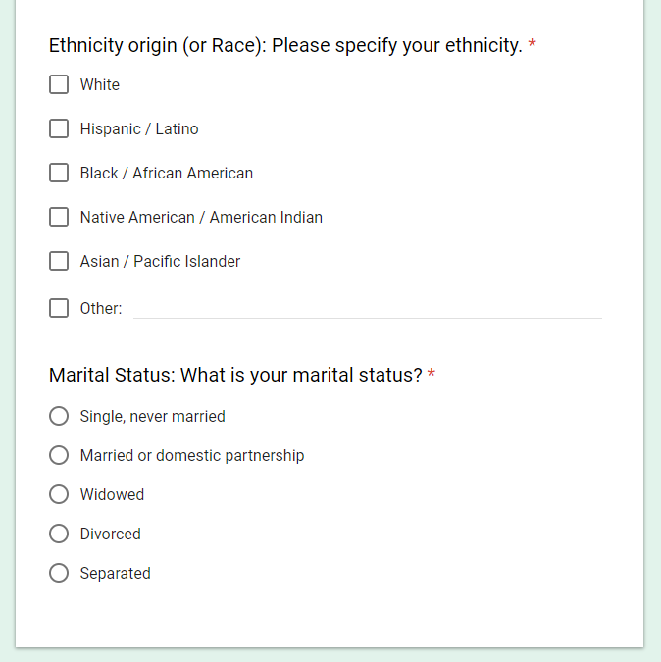
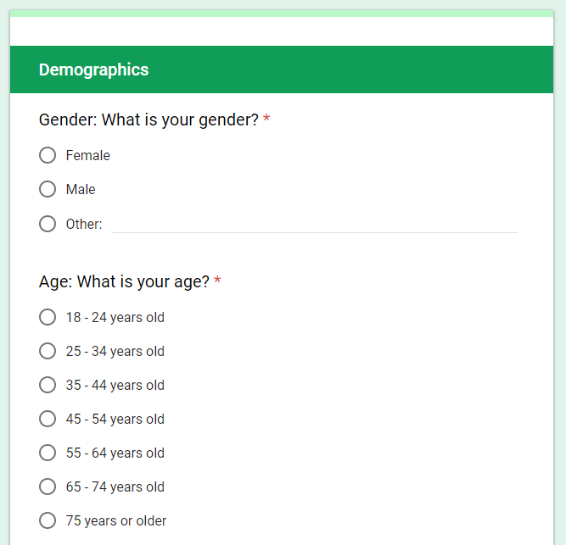
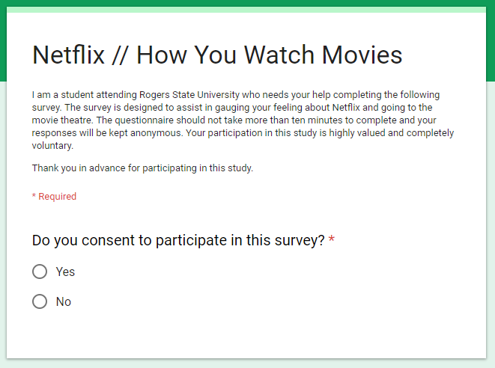
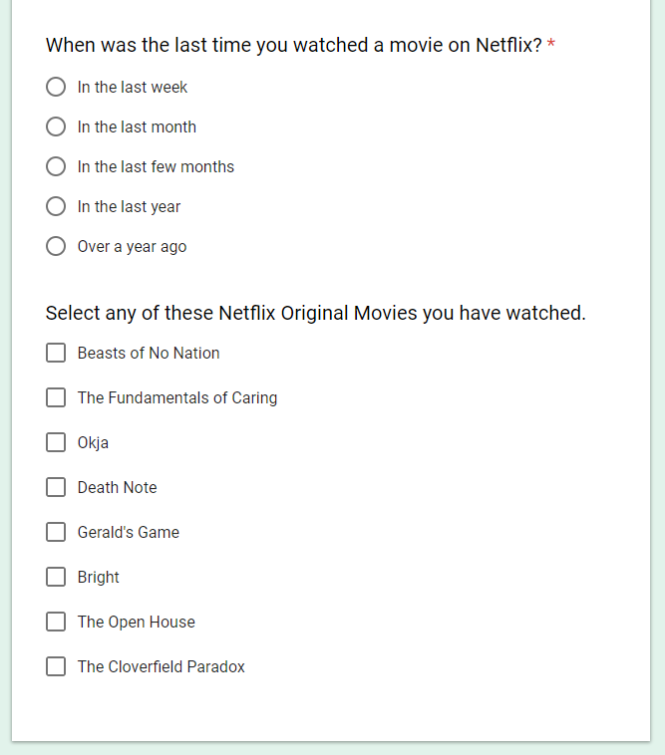
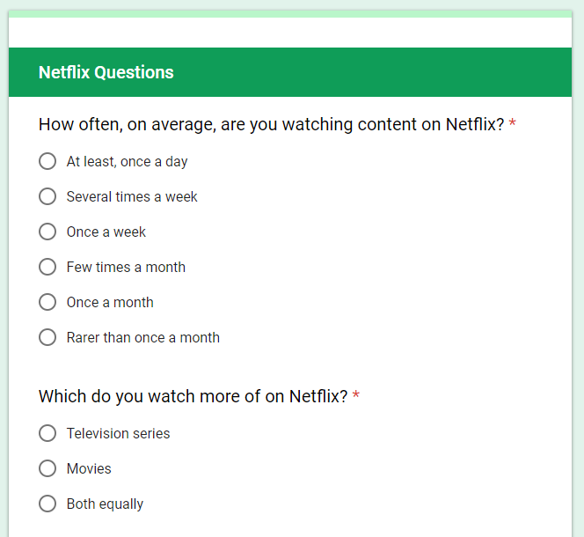
Appendix

